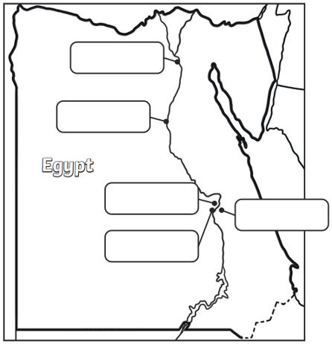

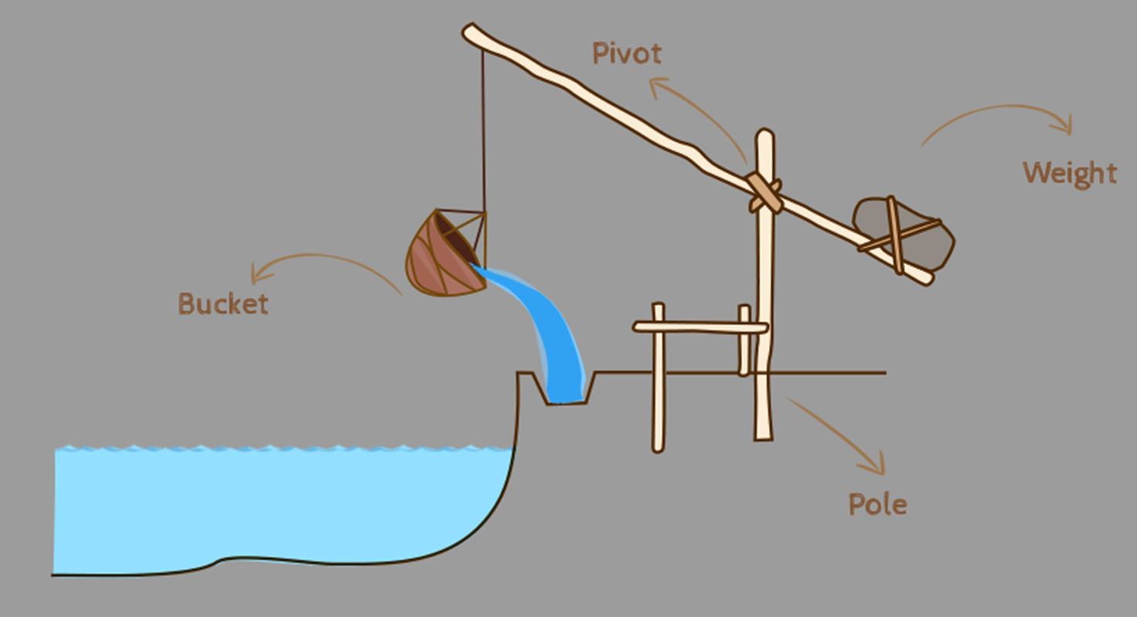

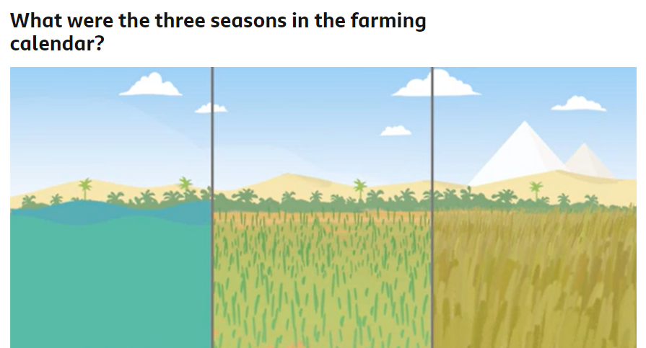

Shemu
Peret
Akhet

Akhet was the _______________ season. This was important as the floods would leave ___________ _____________ behind which helped the crops to grow.
Peret was the __________________ season. This was the time that the ____________________ grew. The farmers would water the plants using the water from the _________________ ________________ .

Shemus was the __________________ season. This was the time that the crops were _________________ . The seeds from the crops would be ____________________ so that they could be __________________ again after the _________________ season had finished.

